**Instruction Manual to Dashboard Honor of Kings**

Welcome to our dashboard “Honor of Kings”.

This dashboard is mainly used to give new players a comprehensive introduction of this popular mobile game - “Honor of kings”. In this dashboard, you will learn this game from scratch. You can not only explore different positions of heroes and compare the attributes among all the heroes, but also learn about heroes’ winning rates and combinations of positions for 5v5 battle.

**PART 1: Introduction of Honor of Kings**

When you click on the left button, the dashboard will show you the introduction of the game and how you play and win the game.

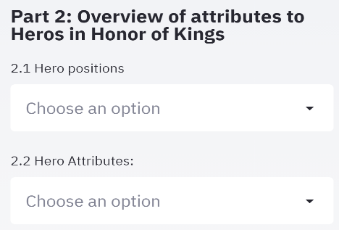**PART 2**: **Overview of heroes’ attributes**:

There are mainly two parts in this section: part 2.1 is used to help you learn about hero positions and which heroes are in the particular position; part 2.2 is used to explore some attributes of all the heroes in the game, in order to help you choose your suitable hero based on their strength.

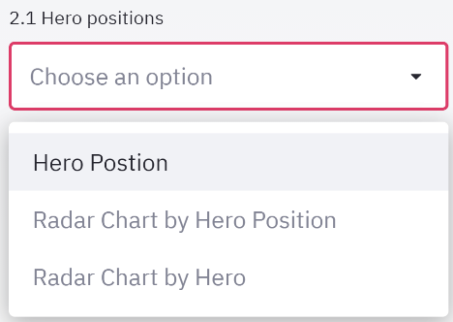

In part 2.1, there are 3 parts: hero position introduction, radar charts of showing the attributes of each position, and radar charts of showing the attributes of each hero in the position.

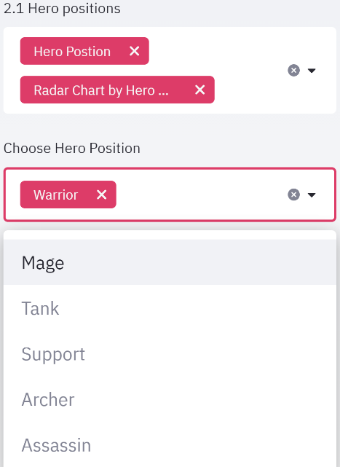

By choosing radar chart by hero position, you will see a new drop-down list for you to choose different positions. There are total 6 position’s heroes you can choose in this game, they are: Mage, Tank, Support, Archer, Assassin and Warrior. You can also choose multiple positions to make a comparison (Exhibit 1).

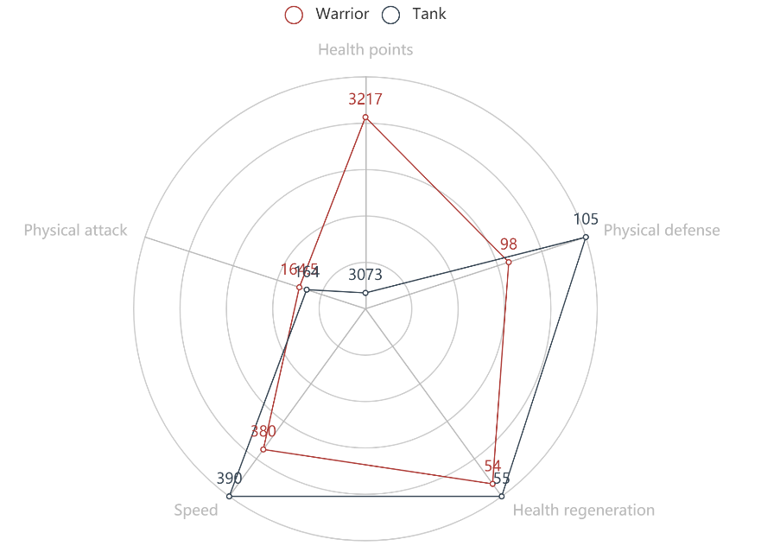

Exhibit 1

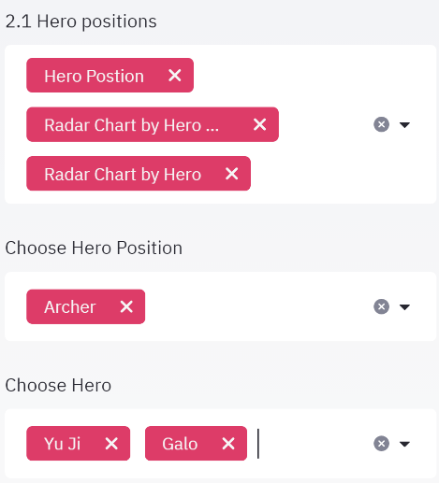By choosing ‘Rader chart by hero’ button in the first list, a new drop-down list will appear for you to choose heroes ‘name, in the position you selected before. After you select heroes ‘name, you can see the radar chart to compare each hero’s viability, attack damage, skill effect and difficulty.

For example, if you choose ‘Archer’ as the hero position, and choose Yu ji and Galo as two heroes you want to compare, then the radar chart can be shown (Exhibit 2):

From this chart, you can find that Galo has higher attack damage and skill effect ratings and has lower difficulty, so this hero maybe more suitable for new players.

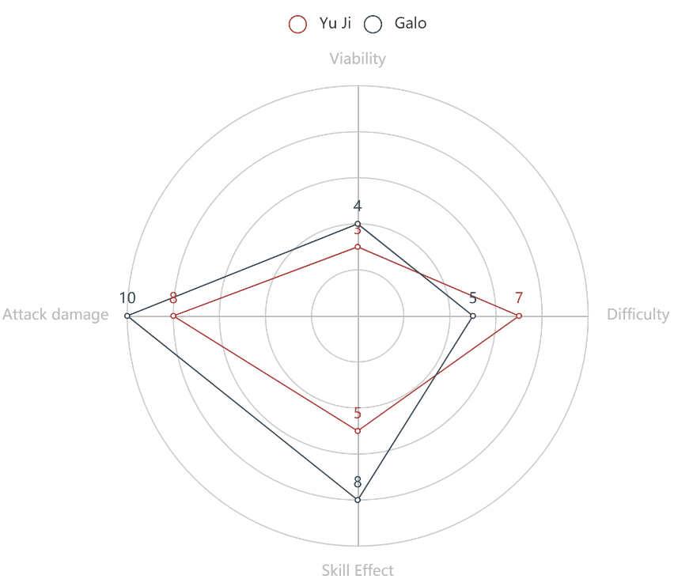

Exhibit 2

In part 2.2, the dashboard will show you 5 interactive graphs related to different hero attributes: Hero speed, health points, health regeneration, physical defense and physical attack.

The first graph is about hero speed. When your cursor stays on the red point, it will tell you the hero name and its speed without any equipment addition. (Exhibit 3)

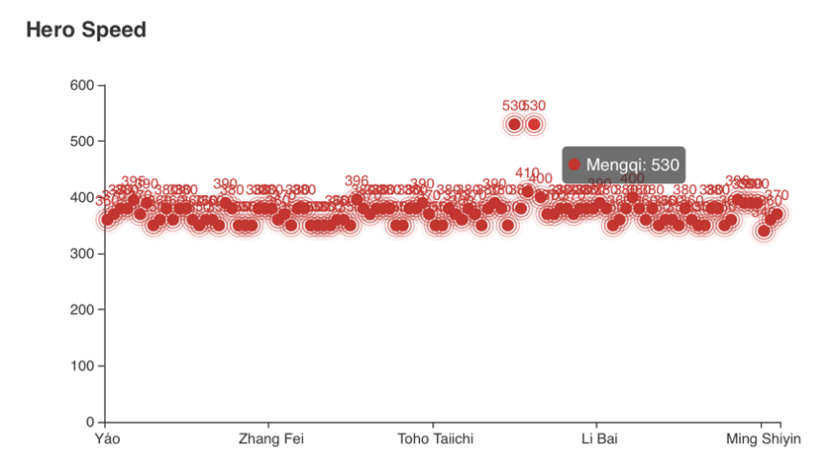

Exhibit 3

The second graph is a bar chart about hero health points(Exhibit 4). You can put your cursor on the bar and know the hero name and its initial health points. To learn more about other heroes, you can drag the bar back and forth at the bottom of the graph. You can also move the mouse wheel up and down to enlarge or shrink the size of the bar to show more or less heroes. The highest dotted line is the maximum health points among these heroes shown in the chart. The middle line is the average health points, and the lowest line is the minimum health points.

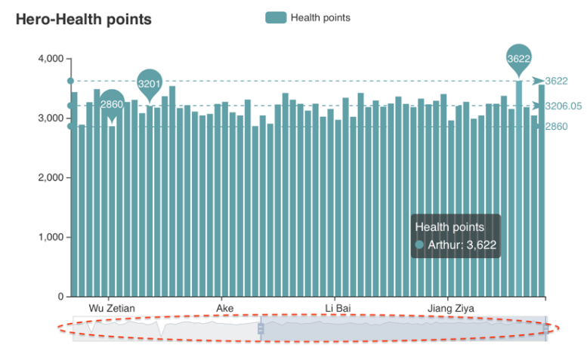

Exhibit 4

The following three graphs are about health regeneration, physical defense and physical attack. The application methods of them are same as the health points chart.

**PART 3: Winning Rate**

Novice players in the game, always hope that they can win more. Here, based on the data of the Honor of Kings 2020 KPL, we try to find out the hero with higher winning rate, or even the combination with higher winning rate.

Despite there is a gap between the skills of professional players and those of novice players, considering that the opponents of professional players are also professional, the gap can be offset to some extent. Besides, the KPL data is much more valuable, since professional players were fighting for each round.

**3.1 Single winning rate**

Here, select the hero through the drop-down box, or directly enter the name of the hero in the column, you can see the winning rate.

At the same time, the table below shows the winning rate or winning rounds of all heroes in a descending order.

**3.2 Double-Hero Winning Rate**

Here, select the hero through the drop-down box, or directly enter the combination of the heroes name in the column, you can see the winning rate.

At the same time, the table below shows the winning rate or winning rounds of all hero combinations in a descending order.

**3.3 Double-Hero Winning rate Heat-map**

There are 101 heroes in the game. When calculating the winning rate of two heroes, sometimes there is no match between the heroes. Hence, in order to distinguish, we artificially set the winning rate as - 1.

The lighter the color, the lower the winning rate; the darker the color, the higher the winning rate.

**3.4 High-Winning-Rate Heroes Combination**

There are 6 positions in the game. For novice players, how to choose the right combination and start a game? Based on the data of 2020 Fall KPL, we counted the combination with the highest winning rounds and the highest winning rate. The table below help you find the best combination.